Glossary
Term | Simple Definition
Feature | A major functionality or area being tested.
Story | A smaller user-focused part of a feature.
Severity | Indicates the importance of a test failure.
Suite | A logical collection/group of tests.
Trend | A view of test results across multiple executions to identify patterns.

Technical Learning Report: Week 5 Day 3
Date: October 3, 2026
Intern Name: Shekhar Singh Rawal
Subject: Advanced Pytest and Allure Reporting

1. Objective
The objective of Day 3 was to go deeper into Pytest and Allure reporting by learning how test cases can be organized, described, and prioritized within an automated test report. The practical work focused on Allure features, stories, titles, severity levels, steps, and test organization through behaviors and suites. The user purchasing module from the previous day's work was extended with Allure metadata to produce a more structured and meaningful test report.

2. Advanced Allure Reporting
Allure provides metadata and organization features that make automated test reports easier to understand.Instead of displaying only:
test passed
test failed
Allure allows the tester to describe:
- What functionality is being tested
- What user story the test belongs to
- What the test is called
- How serious a failure is
- What steps were performed
- How tests are grouped
The practical implementation used decorators such as:
@allure.feature()
@allure.story()
@allure.title()
@allure.severity()

3. Feature

Definition
A Feature represents a major functionality or functional area of the application being tested.
It answers:
"Which major part of the application does this test belong to?"

Example
@allure.feature("User Validation")
def test_username_length():
The practical tests were organized into features such as:
Feature | Purpose
User Validation | Validate user information
Balance | Validate user's balance
Items | Validate purchased and stock items
Shopping | Validate shopping calculations and balance

4. Story

Definition
A Story represents a smaller functionality or user-focused part of a feature.
It answers:
"Which specific part of this feature is being tested?"

Example
@allure.feature("User Validation")
@allure.story("Username")
def test_username_length():
...
Here:
- Feature = User Validation
- Story = Username
This creates a hierarchy:
User Validation
↓
Username
↓
Username Tests

Practical Examples
Feature | Story
User Validation | Username
Balance | Balance Validation
Items | Purchased Items
Items | Stock
Shopping | Total Calculation
Shopping | Balance Check

5. Title

Definition
The Title gives an understandable name to an individual test case in the Allure report.
It answers:
"What exactly is this test checking?"

Example
@allure.title("Verify username length")
def test_username_length():
Instead of displaying only the Python function name:
test_username_length
Allure can display:
Verify username length

Practical Examples
Python Test | Allure Title
test_username_length() | Verify username length
test_balance_greater_than_zero() | Verify balance is greater than zero
test_total_calculation() | Verify total price calculation
test_sufficient_balance() | Verify user has sufficient balance
This makes the report easier for both technical and non-technical team members to understand.

6. Severity

Definition
Severity indicates the importance of a test failure from the testing/reporting perspective.
The practical code used:
@allure.severity(allure.severity_level.CRITICAL)
and:
@allure.severity(allure.severity_level.NORMAL)

Example
@allure.feature("Shopping")
@allure.story("Total Calculation")
@allure.title("Verify total price calculation")
@allure.severity(allure.severity_level.CRITICAL)
def test_total_calculation():
...
The total calculation test was marked CRITICAL because incorrect purchase calculation directly affects the shopping process.

Severity Examples
Severity | Practical Meaning | Example
TRIVIAL | Very minor impact | Small cosmetic issue
MINOR | Low-impact functionality issue | Minor UI behavior
NORMAL | Normal functional issue | Username validation
CRITICAL | Very important functionality | Purchase total calculation
BLOCKER | Prevents major testing/application flow | Login completely unavailable
The severity level is metadata used to communicate the importance of the test within the report.

7. Allure Steps

Definition
An Allure Step divides a test into understandable actions.
It answers:
"What did the test do before reaching the result?"

Example
with allure.step("Check username length"):
assert len(userName) < 30
Another example:
with allure.step("Check total price"):
assert total == 2500
Instead of showing only the assertion, the Allure report can show the action as a readable test step.

Practical Flow
Test
↓
Step: Check total price
↓
Assertion
↓
Pass / Fail

8. Behaviors
Allure's Behavior-based organization groups tests around application behavior using concepts such as:
Feature
↓
Story
↓
Test
For the practical project:
Shopping
├── Total Calculation
│ └── Verify total price calculation
│
└── Balance Check
└── Verify user has sufficient balance
Another example:
User Validation
└── Username
├── Verify username length
└── Verify username does not contain invalid characters

Why It Is Useful
Behavior-based organization allows a QA engineer to understand what functionality the tests represent rather than seeing only technical test-function names.

9. Suites

Definition
A Suite is a logical grouping of tests.
It answers:
"Which collection of tests should be considered together?"
For example, tests could be organized into:
User Validation Suite
Balance Suite
Items Suite
Shopping Suite
The provided code primarily used Feature and Story decorators for organization. It did not explicitly include an allure.suite() decorator.
Therefore, the suite concept was studied as part of advanced Allure organization, while explicit suite metadata was not part of the provided implementation.

Example
Conceptually:
@allure.suite("Shopping Tests")
def test_total_calculation():
...
This would place the test inside a Shopping test suite.

10. Trends

Definition
Trends show how test execution results change across multiple test runs.
For example:
Run 1 → 8 Passed, 1 Failed
Run 2 → 9 Passed, 0 Failed
Run 3 → 7 Passed, 2 Failed
By looking at results over time, QA teams can identify patterns such as:
- Increasing failures
- Repeated failures
- Improving stability
- Regression patterns
- Changes in test execution results

QA Example
If a test passes for several executions and starts failing after a new build, the trend can help indicate that the latest change may have introduced a regression.
Important: Trends require multiple executions/results to become meaningful; a single test run does not establish a trend.

11. Practical User Testing Module
The practical module used:

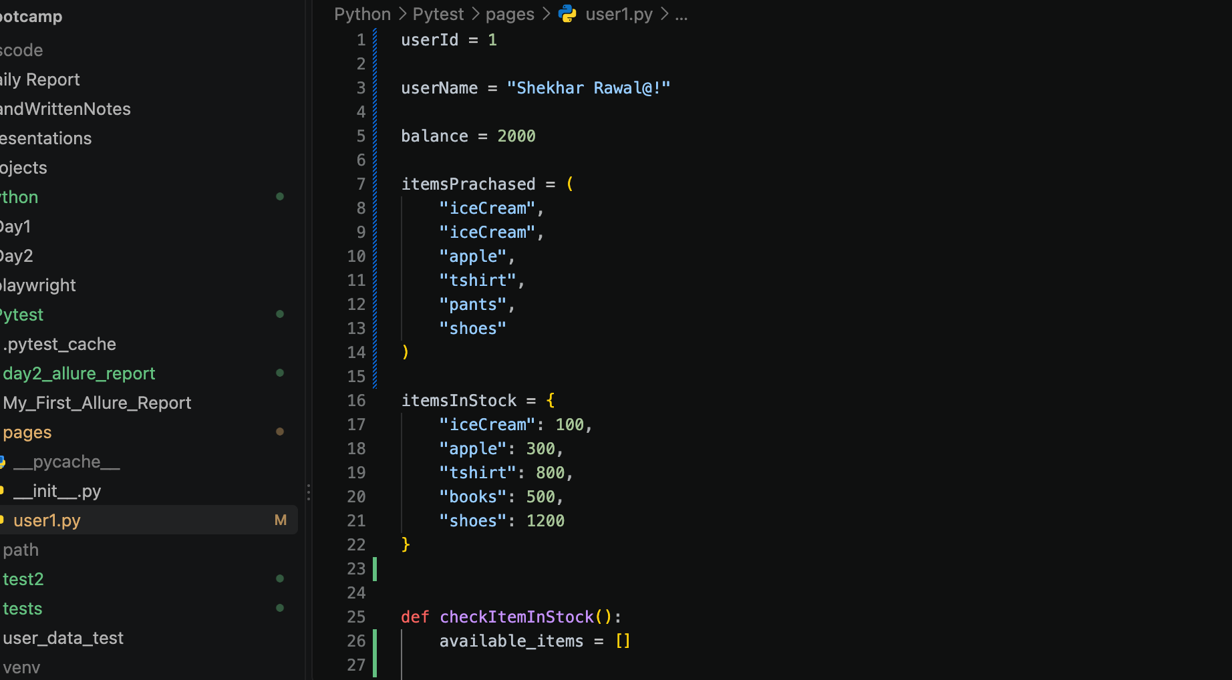
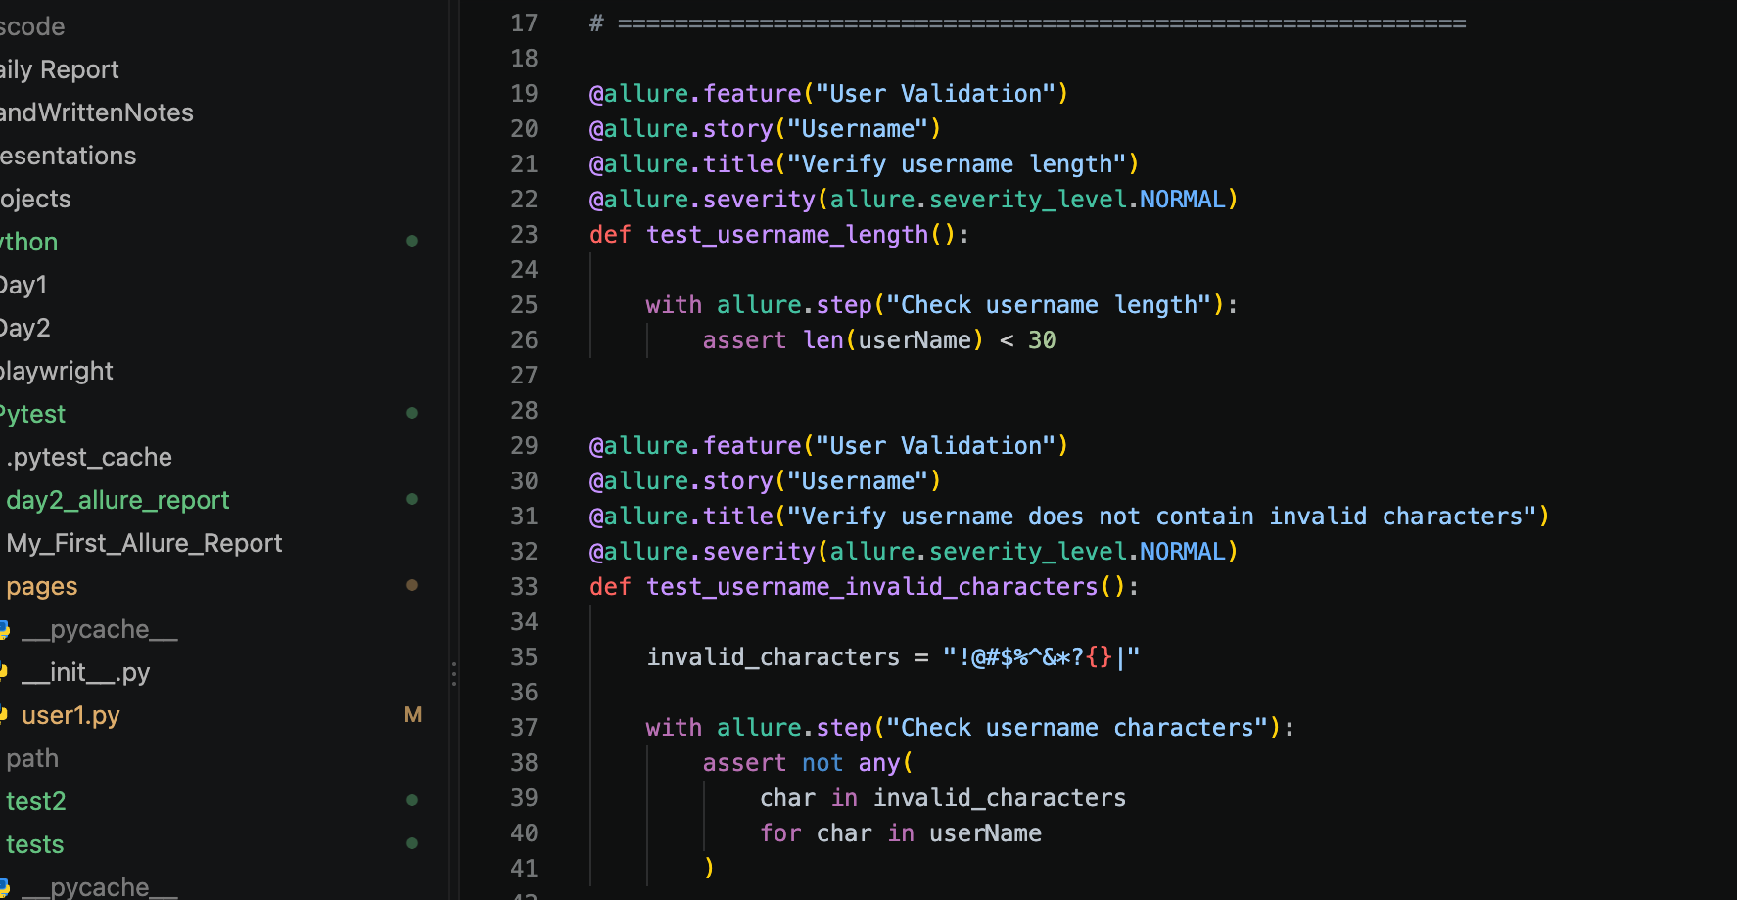

12. Test Organization Implemented
The tests were organized into the following Allure structure:
Feature | Story | Example Test | Severity
User Validation | Username | Verify username length | Normal
User Validation | Username | Verify invalid characters | Normal
Balance | Balance Validation | Verify balance > 0 | Normal
Balance | Balance Validation | Verify balance is integer | Normal
Items | Purchased Items | Verify purchased items are tuple | Not specified
Items | Stock | Verify stock is dictionary | Not specified
Items | Stock | Verify purchased items available | Critical
Shopping | Total Calculation | Verify total price | Critical
Shopping | Balance Check | Verify sufficient balance | Critical
This organization makes the report more readable by connecting individual tests to application functionality.
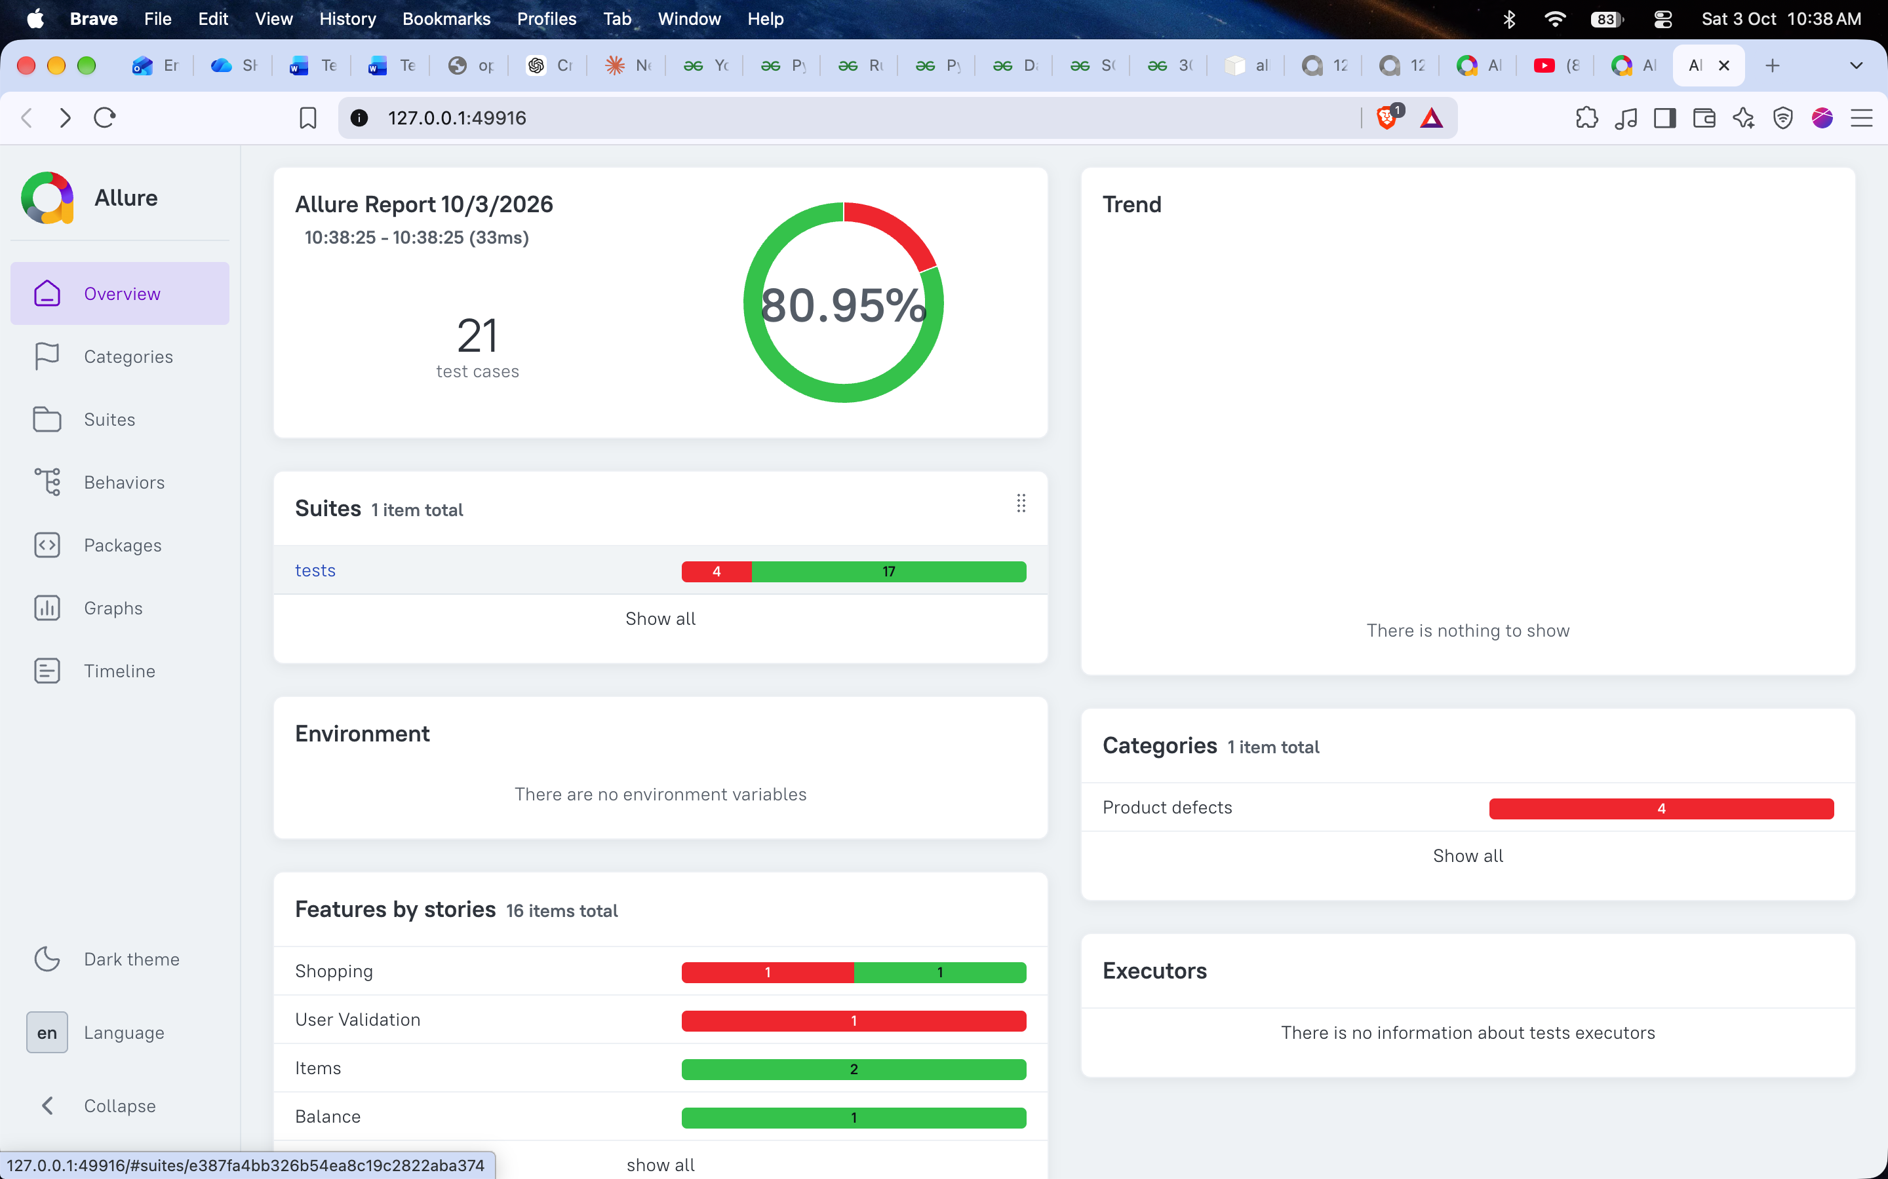

16. Key Findings & Best Practices
- Feature organizes tests around major application functionality.
- Story organizes tests around a smaller user-focused functionality.
- Title makes individual test cases easier to understand in the report.
- Severity communicates the importance of a test failure.
- Allure Steps make individual test actions visible in the report.
- Behaviors provide a Feature → Story → Test organization.
- Suites group related tests into logical collections.
- Trends help monitor test results across multiple executions.

17. Conclusion
Week 5 Day 3 focused on advanced Pytest and Allure reporting. The existing user-testing module was enhanced with Allure metadata including features, stories, titles, severity levels, and test steps. Behavior-based organization through Feature and Story was practiced, while Suites and Trends were studied as additional reporting capabilities. The practical data also demonstrated how incorrect username data and insufficient balance can produce meaningful test failures in an Allure report. This provided a deeper understanding of how automated test results can be organized, prioritized, and monitored over time.

